**Experiment 5**

**Aim:** Design an Automatic Night Lamp.

**Apparatus:** Breadboard, Arduino, Resistances (10K, 220), Jumper wires, LDR, LED.

**Circuit Diagram:**

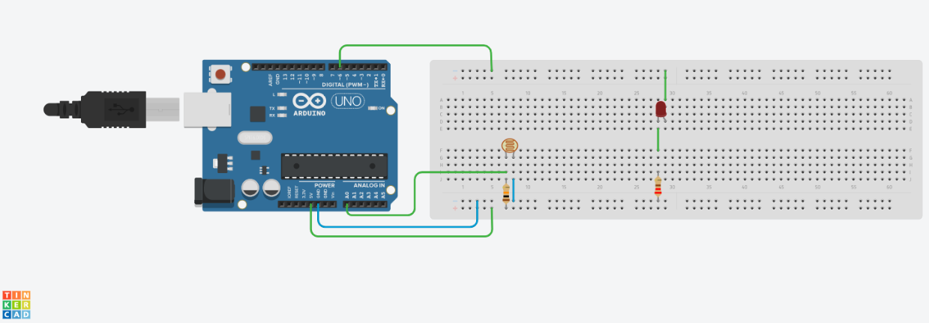

**Theory:**

1. Concept Used:
2. In Arduino, digital pins provide input as well as output but analog pins only provide input.
3. Resistance of LDR decreases with increasing incident light intensity.
4. An analog to digital converter system is a system that converts an analog signal into digital signal.
5. LDR allows LED to glow based on percentage of light falling on it.
6. LED glows when power passes through anode of led and cathode is grounded.
7. Learning & Observations:
8. Learn about different parts of Arduino and how to use them.
9. Learn to use LDR(Light dependent resistance).
10. When light falling on LDR is high then LED does not glow.
11. When light falling on LDR is low then LED will glow.

**Problems and Troubleshooting:**

1. Applying condition on LDR to glow LED.

**Precautions:**

1. Connections should be made carefully and clearly.
2. Using “if-else” carefully.
3. Use right commands for serial monitor to store, show readings.
4. Use right command to store analog reading.
5. Resistance should be used so that led do not damage.
6. Storing the analog reading.

**Learning Outcomes:**

1. Using Arduino and defining output pins.
2. Using void setup and void loop.
3. Using LDR to glow LED depending on condition required.
4. Using Serial monitor.
5. How to print on serial monitor.

**Result:** Automatic Night Lamp worked properly after running Arduino.